EV Delivery Job India: Electric Vehicle Se Karo Delivery, Petrol Ka Jhanjhat Khatam
By Vahan · Updated: 6 Jul 2026 | Published: 6 Jul 2026
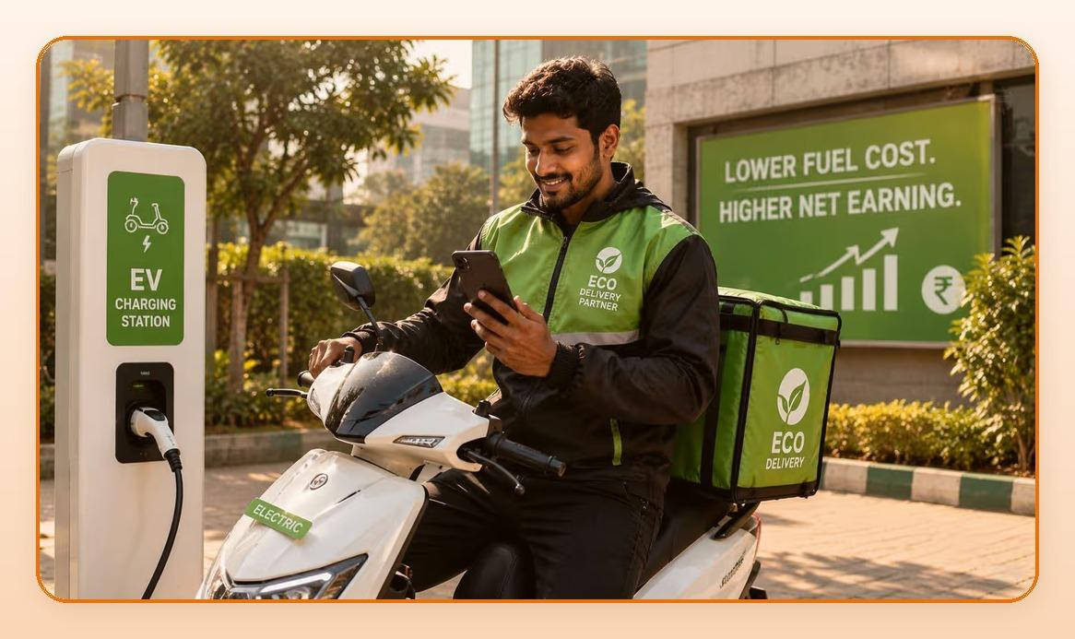
Summarize with ChatGPT · Gemini · Claude · Perplexity (tool icons in design)

Key Takeaways
- Electric vehicle par kaam karo, fuel cost almost zero karo, aur net earning significantly badha lo.
- Sirf fuel aur maintenance ki saving se ek EV rider saal mein Rs.60,000 se Rs.80,000 zyada bacha sakta hai.
- Zomato, Swiggy, Blinkit, Zepto, sab ne EV-first policies announce ki hain.
- India ka EV ecosystem tezi se grow kar raha hai; platforms EV riders ko prefer karte hain; government incentives available hain.

Table of Contents
- EV Delivery Job Kyon Smart Choice Hai: Simple Math
- India Mein EV Delivery Ka Scope: Industry Kahan Ja Rahi Hai?
- EV Delivery Job Ke Liye Eligibility aur Requirements
- Top EV Models Jo Delivery Ke Liye Best Hain
- EV Delivery Mein Challenges: Jo Jaanna Zaroori Hai
- EV Platforms aur Incentives: Kahan Se Milega Sabse Zyada Faida?
- FAQs
- Conclusion

Petrol ke badhte daam delivery partners ke liye ek bada headache ban gaye hain. Jo pehle Rs.25,000 earn hota tha, usme se Rs.5,000-Rs.7,000 sirf petrol mein chale jaate hain. Yahan EV delivery ka game-changer role aata hai. Electric vehicle par kaam karo, fuel cost almost zero karo, aur net earning significantly badha lo.
India mein EV delivery revolution already shuru ho chuka hai. Zomato, Swiggy, Blinkit, Zepto, sab ne EV-first policies announce ki hain. Aur kai platforms EV lene ke liye subsidies aur leasing options bhi de rahe hain. Yeh trend nahi hai, yeh future hai.

EV Delivery Job Kyon Smart Choice Hai: Simple Math
Ek normal petrol bike wale aur ek EV wale delivery partner ki monthly earning compare karte hain:
Factor | Petrol Bike Rider | EV Rider
Gross Monthly Earning | Rs.25,000 | Rs.25,000
Fuel Cost | Rs.5,000 - Rs.7,000 | Rs.500 - Rs.800 (charging)
Maintenance Cost | Rs.1,500 - Rs.3,000 | Rs.500 - Rs.1,000
Net Take-Home | Rs.15,000 - Rs.18,500 | Rs.22,700 - Rs.24,000
Annual Savings | Baseline | Rs.60,000 - Rs.80,000 extra

Sirf fuel aur maintenance ki saving se ek EV rider saal mein Rs.60,000 se Rs.80,000 zyada bacha sakta hai. Yeh ek phone ki EMI, ghar ka kharcha, ya college fees ho sakti hai.

India Mein EV Delivery Ka Scope: Industry Kahan Ja Rahi Hai?
Indian government ka target hai ki 2030 tak commercial vehicles ka 70% electric ho. Delivery sector is transition mein sabse aage hai. Yahan kuch important facts hain:
- Zomato ne 2024 mein target announce kiya: 2030 tak 100% EV fleet
- Swiggy Instamart aur Blinkit dono EV delivery partners ko extra incentives de rahe hain
- Bounce, Yulu, Zypp Electric jaise EV rental platforms ne last-mile delivery ke liye dedicated programs shuru kiye hain
- FAME-II scheme ke under EV two-wheelers par Rs.15,000 tak ki government subsidy available hai
- EV charging infrastructure 2024-25 mein 3x speed se expand hua hai

EV Delivery Job Chahiye? Abhi Apply Karein.
Get Started

EV Delivery Job Ke Liye Eligibility aur Requirements
EV delivery job ki requirements petrol bike delivery se almost same hain:
- Age: 18 saal ya usse zyada
- Valid driving licence (2-wheeler)
- Smartphone (koi bhi Android chalega)
- Aadhaar Card aur PAN Card
- EV: Apni ya leased/rented (platforms help karte hain)
- Education: Koi minimum nahi
Sabse achhi baat: agar apni EV nahi hai, to tension mat lo. Zypp Electric, Bounce Infinity, Yulu jaise platforms daily/monthly rental par EV dete hain. Kai food delivery companies khud bhi EV leasing schemes offer karti hain apne partners ko.

Top EV Models Jo Delivery Ke Liye Best Hain
Agar aap EV lene ka soch rahe hain, yeh popular choices hain delivery ke liye:
EV Model | Range (per charge) | Approx. Price | Best For
Ola S1 Air | 90-100 km | Rs.80,000 | City delivery, affordable
Ather 450X | 80-90 km | Rs.1.4 lakh | Premium, fast charging
Bounce Infinity E1 | 85 km | Rs.68,999 | Budget-friendly delivery
Hero Vida V1 | 110 km | Rs.1.1 lakh | Long range, reliable
Zypp (Rental) | N/A | Rs.3,000-5,000/month | No upfront cost

Ek typical city delivery mein din mein 60-80 km milta hai. Zyada EV models is range ko easily handle karte hain ek charge mein. Agar route zyada lamba ho, midday charge bhi possible hai kyunki charging stations ab kaafi common hain.

EV Delivery Mein Challenges: Jo Jaanna Zaroori Hai
EV ke fayde toh hain, lekin kuch challenges bhi hain jinka pehle se pata hona achha hai:
- Range anxiety: Ek charge mein limited distance. Solution: Route plan karo, mid-day charging habit banao.
- Charging time: Full charge mein 3-6 ghante lagte hain. Solution: Raat mein charge karo, din mein tension nahi.
- Charging infrastructure: Chhote shehron mein stations abhi limited hain. Solution: Home charging adapter lo.
- Upfront cost: EV petrol bike se mehnga hai. Solution: Leasing ya EMI options use karo, savings jaldi recover ho jaati hain.

EV Platforms aur Incentives: Kahan Se Milega Sabse Zyada Faida?
Platform | EV Incentive | Details
Zomato | Extra Rs.2-5 per delivery | For verified EV riders
Swiggy Instamart | Priority order allocation | EV riders get more orders
Blinkit | Monthly EV bonus | Rs.1,000-2,000 extra/month
Zepto | Onboarding EV subsidy | Up to Rs.5,000 joining bonus
Amazon Flex | EV delivery preferred | Higher block rates for EV

FAQs: EV Delivery Job Ke Baare Mein Common Sawaal
Q: Kya EV delivery ke liye alag licence chahiye?
Nahi. Normal 2-wheeler driving licence EV ke liye bhi valid hai. Koi alag certification ki zaroorat nahi.
Q: Kya EV delivery job metro cities ke bahar bhi possible hai?
Haan, lekin charging infrastructure Tier-2 cities mein abhi build ho raha hai. Home charging adapter ke saath Tier-2 cities mein bhi EV delivery kar sakte hain.
Q: Zypp ya Bounce rental se EV lena sahi rahega?
Agar aap pehle try karna chahte hain toh rental ideal hai. Ek baar confident ho jaao tab purchase ya long-term lease consider karo.
Q: EV ki battery kharab ho jaaye toh kya?
Reputed brands pe warranty hoti hai 3-5 saal ki battery par. Zyada rental services bhi maintenance cover karti hain.
Q: Petrol bike hai toh kya abhi EV switch karna chahiye?
Agar aap regularly 60-80 km daily cover karte ho, EV switch financially very smart decision hai. 12-18 mahine mein cost recover ho jaata hai petrol savings se.

Conclusion: EV Delivery Ka Smart Decision Aaj Hi Karo
Petrol ka dard, maintenance ka kharch, aur oopar se environment ka tension. EV delivery in teeno problems ko ek sath solve karta hai. Net earning badh jaati hai, aur aap ek growing, future-proof category mein hote hain.
India ka EV ecosystem tezi se grow kar raha hai. Platforms EV riders ko prefer karte hain. Government incentives available hain. Yeh sahi time hai switch karne ka. Vahan.co par apply karo, EV delivery shuru karo, aur apni net earning mein fark dekho.

EV Delivery Job Chahiye? Abhi Apply Karein: vahan.co/jobs

